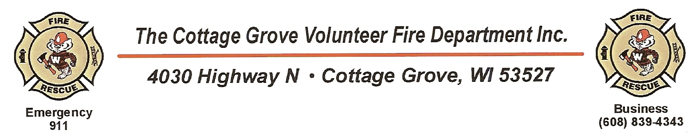
Application For Volunteer Firefighter
Legal Name ______________________________ E-Mail Address ______________________________
Current Address Street ___________________________________ State _____
City _____________________ Zip Code ____________ Date of birth ___________
Phone Number Home ____________Work _____________Cell _____________
Is your residence within the service area of the CGVFD? Yes No
Are you employed within the service area of the CGVFD? Yes NO
What is the extent of your fire department experience? Do you possess any certifications/ licenses? If yes, give details:

Have you ever been convicted of, plead guilty to, or no contest to a crime other than a traffic violation?
Yes No If yes, give details:

Note: A conviction record or pending arrest record does not constitute an automatic bar to employment and will be considered only if there is a substantial relationship to the circumstances of the particular position the Fire Department deems there is a bona fide occupational qualification inherent in the position which requires this information prior to hiring.
Current Employment
Employer Name: _____________________________ Dates Of Employment ________________
Address ____________________________________ Phone Number _____________________
Job Title, Responsibilities
& Duties:

Previous Employment
Please complete the following information for each employer if with current employer less than three years:

Employer Name: _____________________________ Dates Of Employment ________________
Address ____________________________________ Phone Number _____________________
Job Title, Responsibilities
& Duties:

Employer Name: _____________________________ Dates Of Employment ________________
Address ____________________________________ Phone Number _____________________
Job Title, Responsibilities
& Duties:

Do you possess a valid Driver’s License? Yes No State:___ No:________________________

Do you possess a valid commercial Driver’s License? Yes No Type/Class: ________________

Other Qualifications
Describe any specialized training, apprenticeship, skills and extra-curricular activities which may have prepared you for this position:

References:
Please list names and telephone numbers of three people (not relatives) who have knowledge of your abilities, experience and character:
Name: ________________________ Phone number: __________________
Address: ___________________________ City: _________________ State: _____
Zip: _________ Nature of relationship: ______________________________

Name: ________________________ Phone number: __________________
Address: ___________________________ City: _________________ State: _____
Zip: _________ Nature of relationship: ______________________________

Name: ________________________ Phone number: __________________
Address: ___________________________ City: _________________ State: _____
Zip: _________ Nature of relationship: ______________________________

The information that I have provided in this application is true, complete and correct to the best of my knowledge. I understand that any misrepresentation of information shall be considered sufficient reason for withdrawal of an application with the Cottage Grove Volunteer Fire Department.
I hereby authorize the Cottage Grove Volunteer Fire Department or its authorized representatives to verify any information pertaining to my employment including, but not limited to criminal history, driving record, or educational records.

__________________________________ __________________
Signature Date

